Chapter 9, Solution 25.

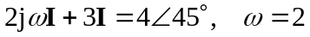
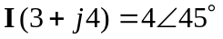
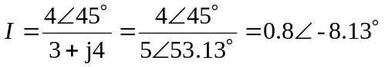
Therefore, i(t) = 800cos(2t – 8.13) mA

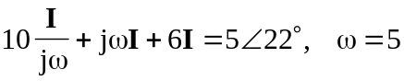
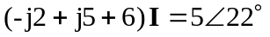
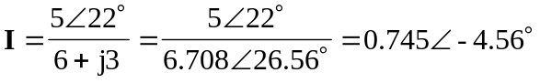
Therefore, i(t) = 745 cos(5t – 4.56) mA

